DSS2 Final Project Report: Todo Management API
Student Name: Titkov Andrii (2419050)
Course: SE2

1. Project Overview
This document outlines the implementation details for the Todo Management API. The backend was developed using ASP.NET Core 9.0 and follows RESTful API principles. The application is containerized using Docker and includes additional integrations like Redis for caching and RabbitMQ for event publishing.
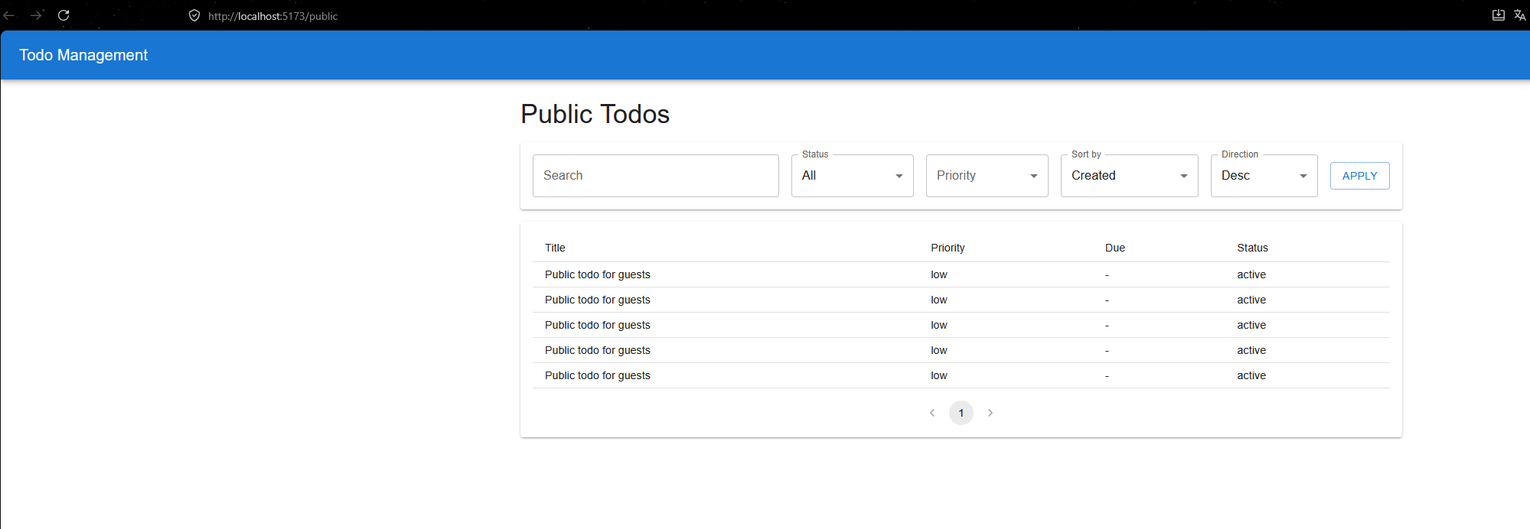
2. How to Run Locally
To run the project on a local machine, please follow these steps:
- Start the Infrastructure: Open a terminal in the root backend directory and start the required containers (PostgreSQL, Redis, RabbitMQ) using Docker Compose: docker-compose up -d db redis rabbitmq
- Apply Database Migrations: Open the Package Manager Console in Visual Studio and run: Update-Database (This will create the TodoDb database and apply the necessary schemas).
- Run the API: Start the application using the Todo.Api profile in Visual Studio. The backend will be available at http://localhost:3087.
- Run the Frontend (Optional): Navigate to the frontend folder, run npm install, and then npm run dev to start the client application.
3. Database Setup and Schema
I chose PostgreSQL as the primary relational database. Entity Framework Core (Code-First approach) was used to define the schema and manage migrations.
The database consists of two main tables:
- Users: Stores user credentials with BCrypt password hashing.
- Todos: Stores tasks with a foreign key linking to the respective User.
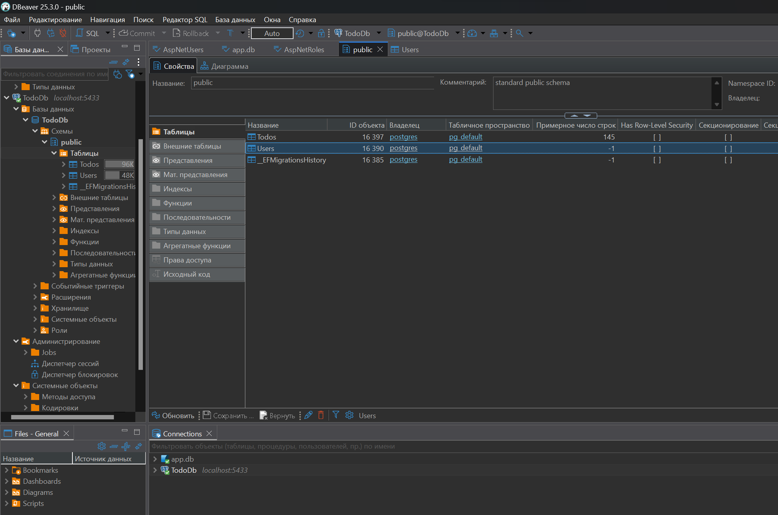
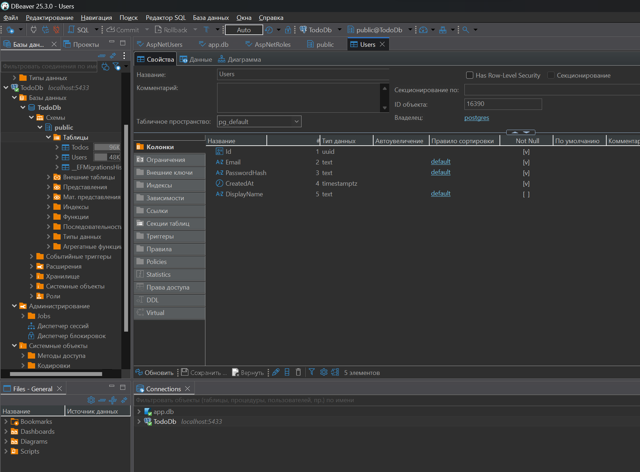
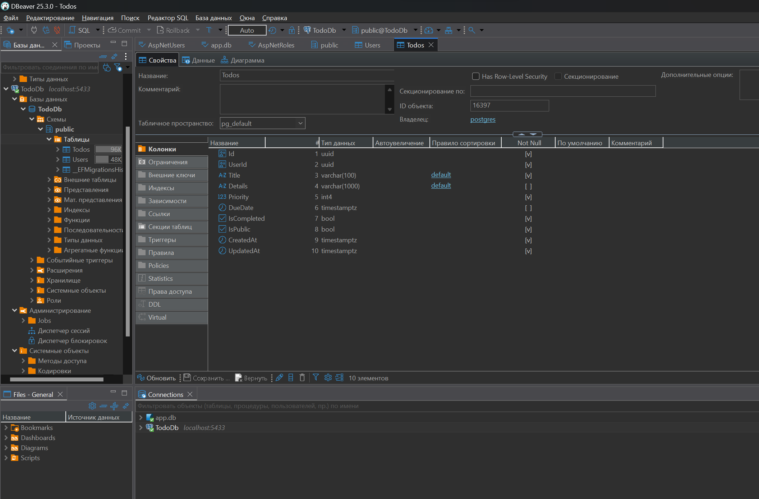
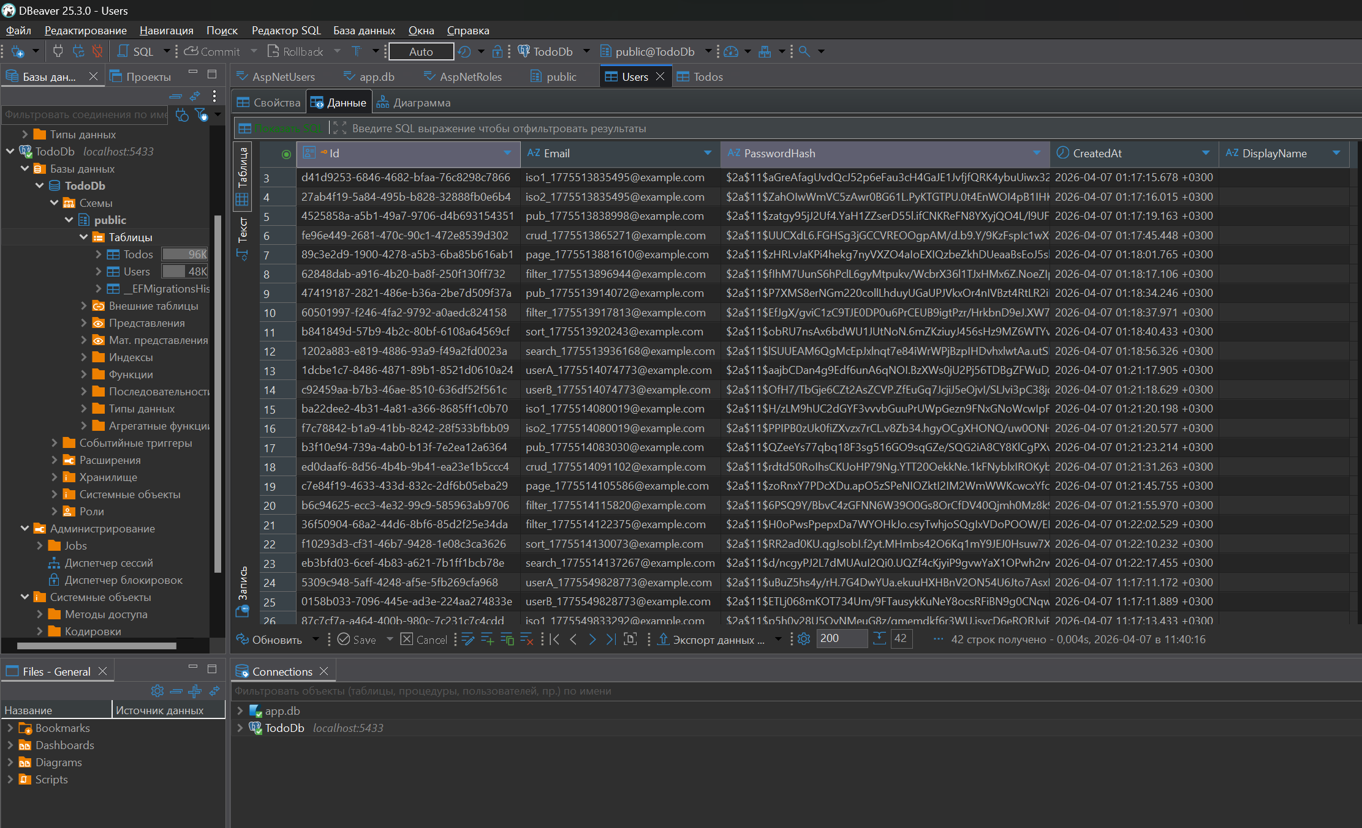
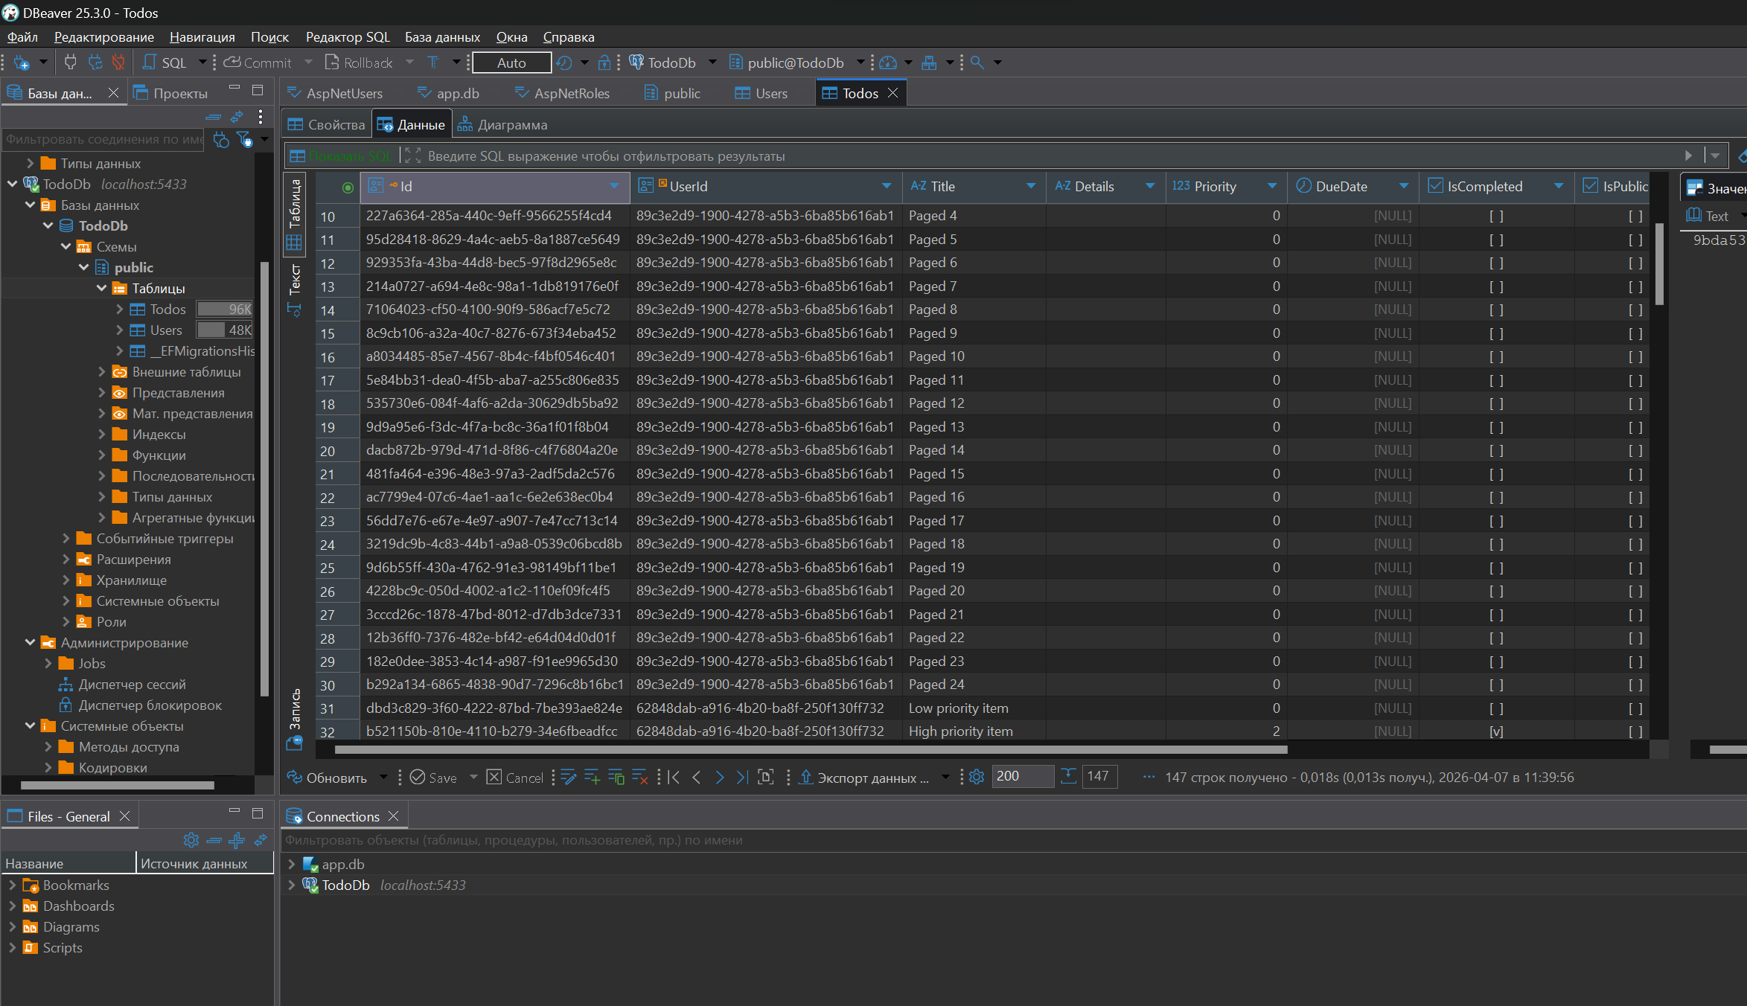
4. API Documentation (Swagger)
Swagger/OpenAPI is integrated into the project to provide a clear UI for testing the endpoints. It includes JWT Bearer authentication support. Users can obtain a token via the /api/auth/login endpoint and use the "Authorize" button to access protected CRUD operations.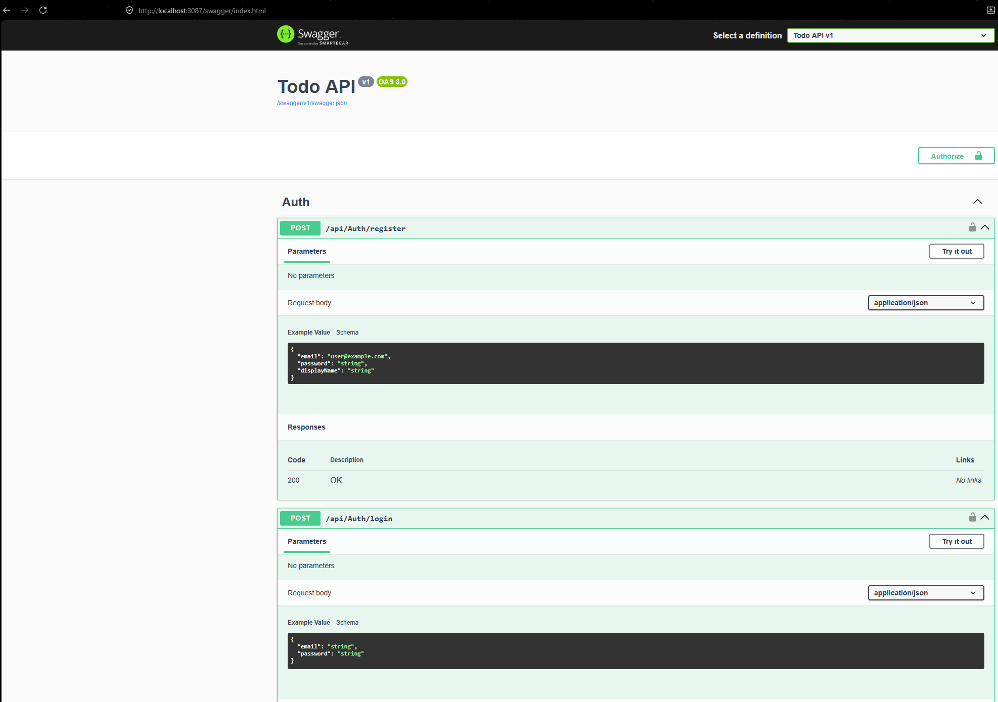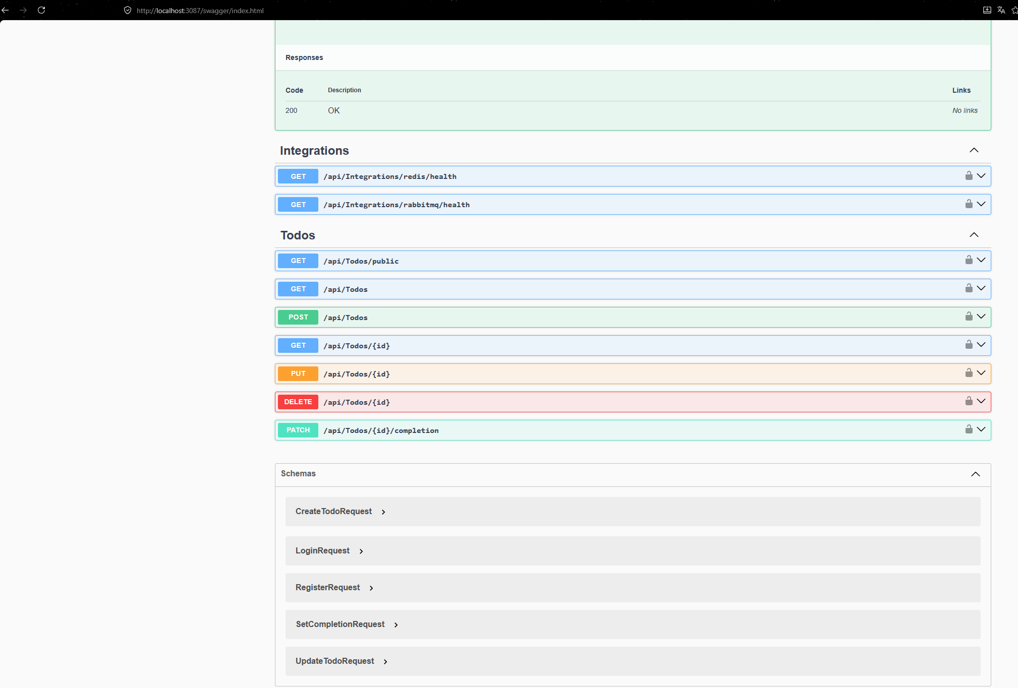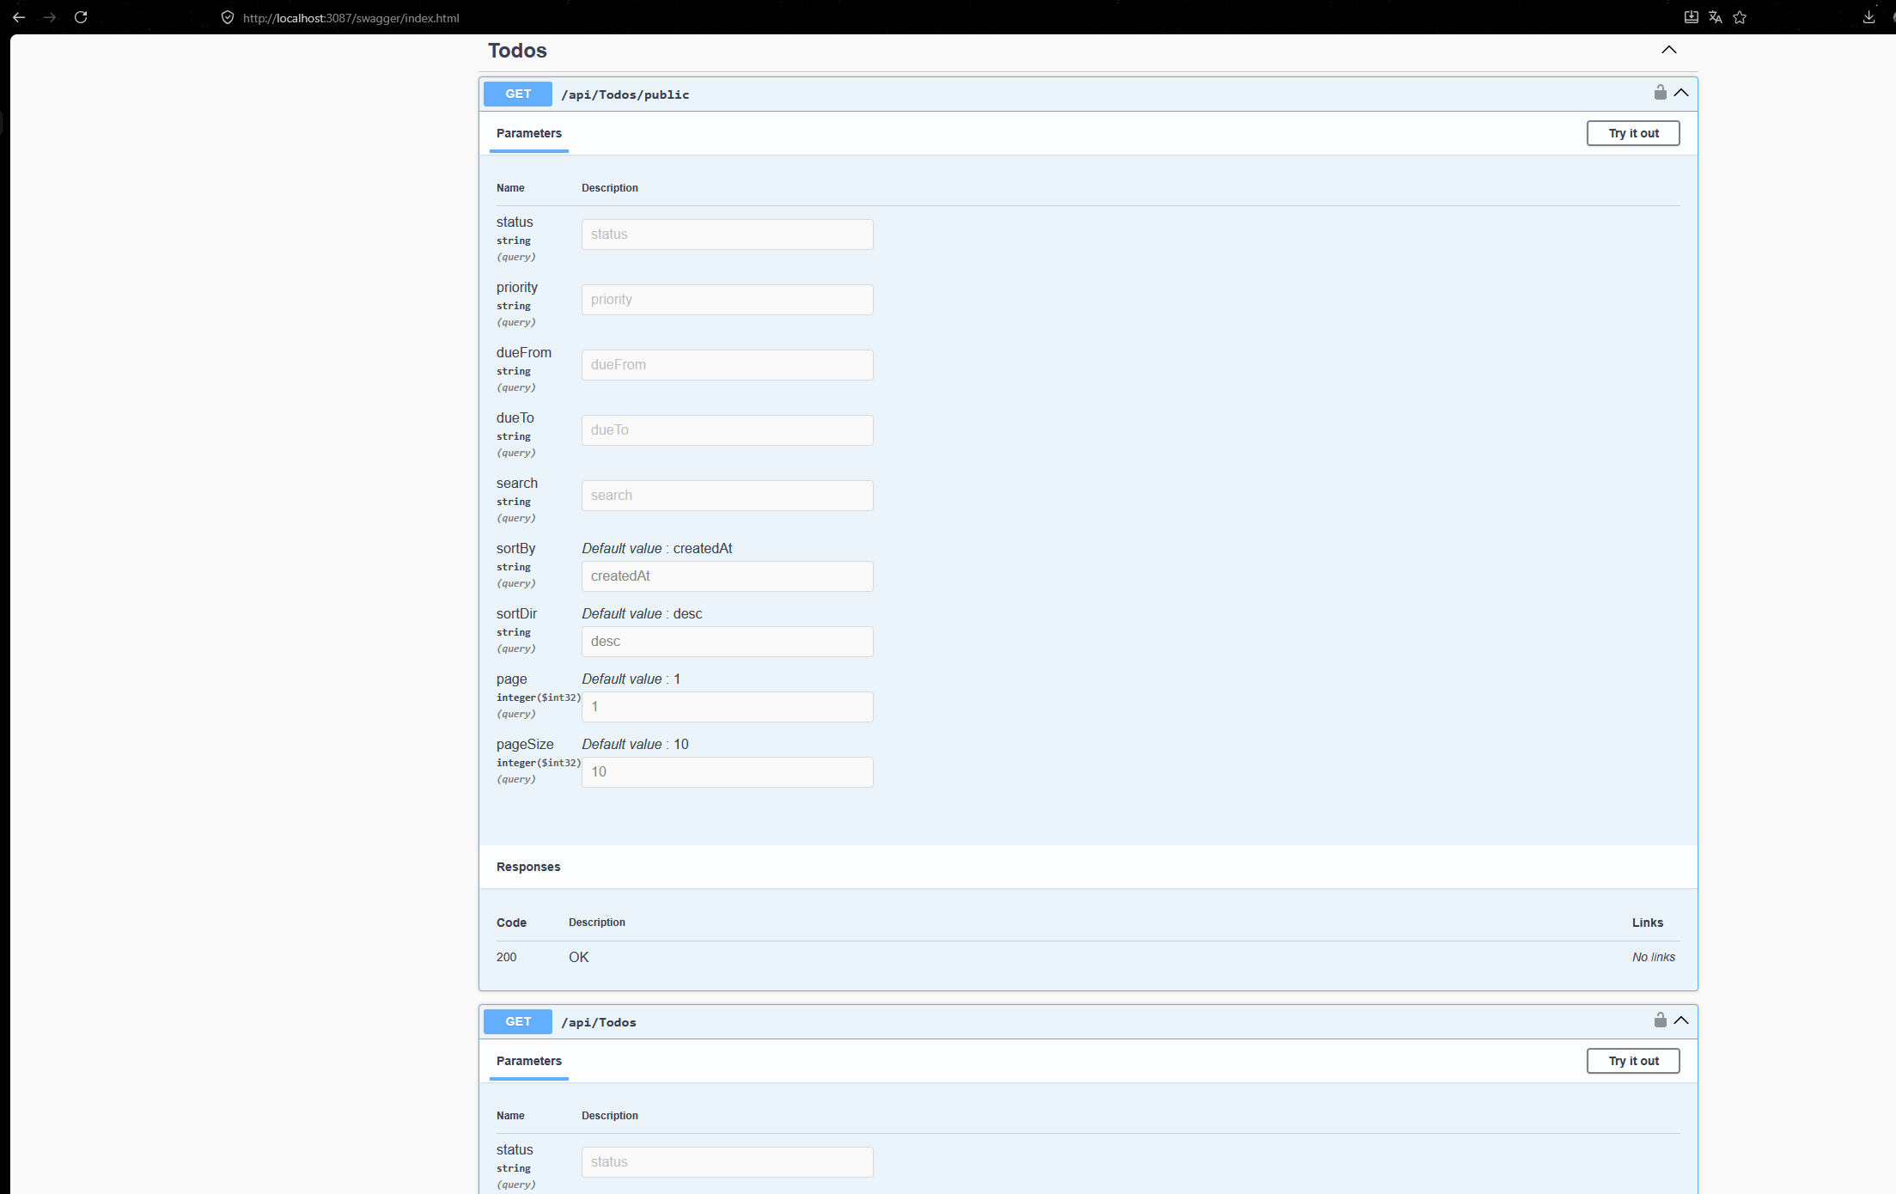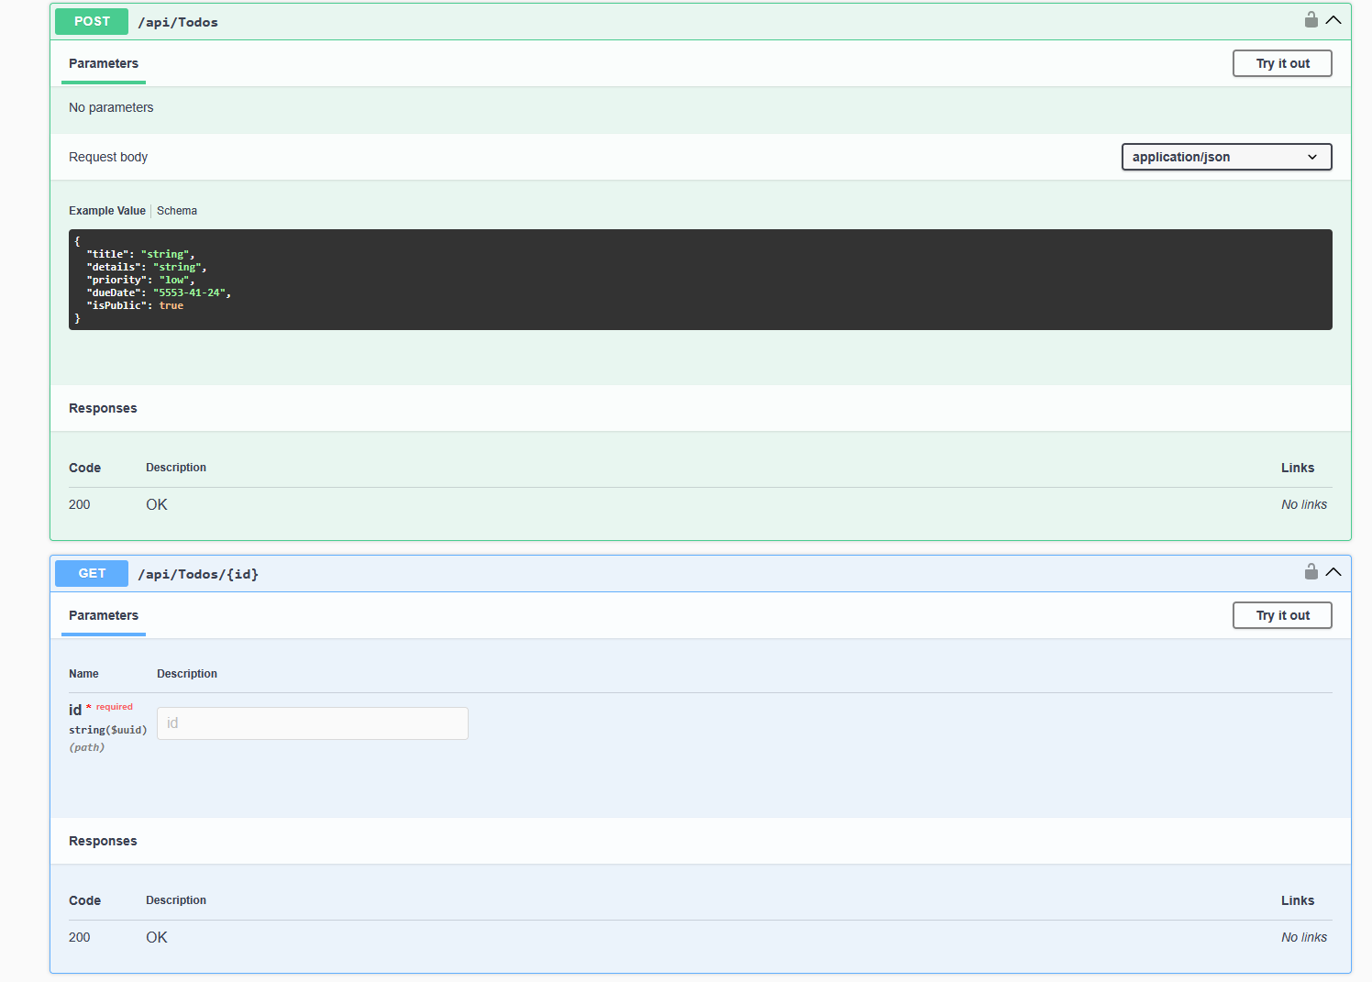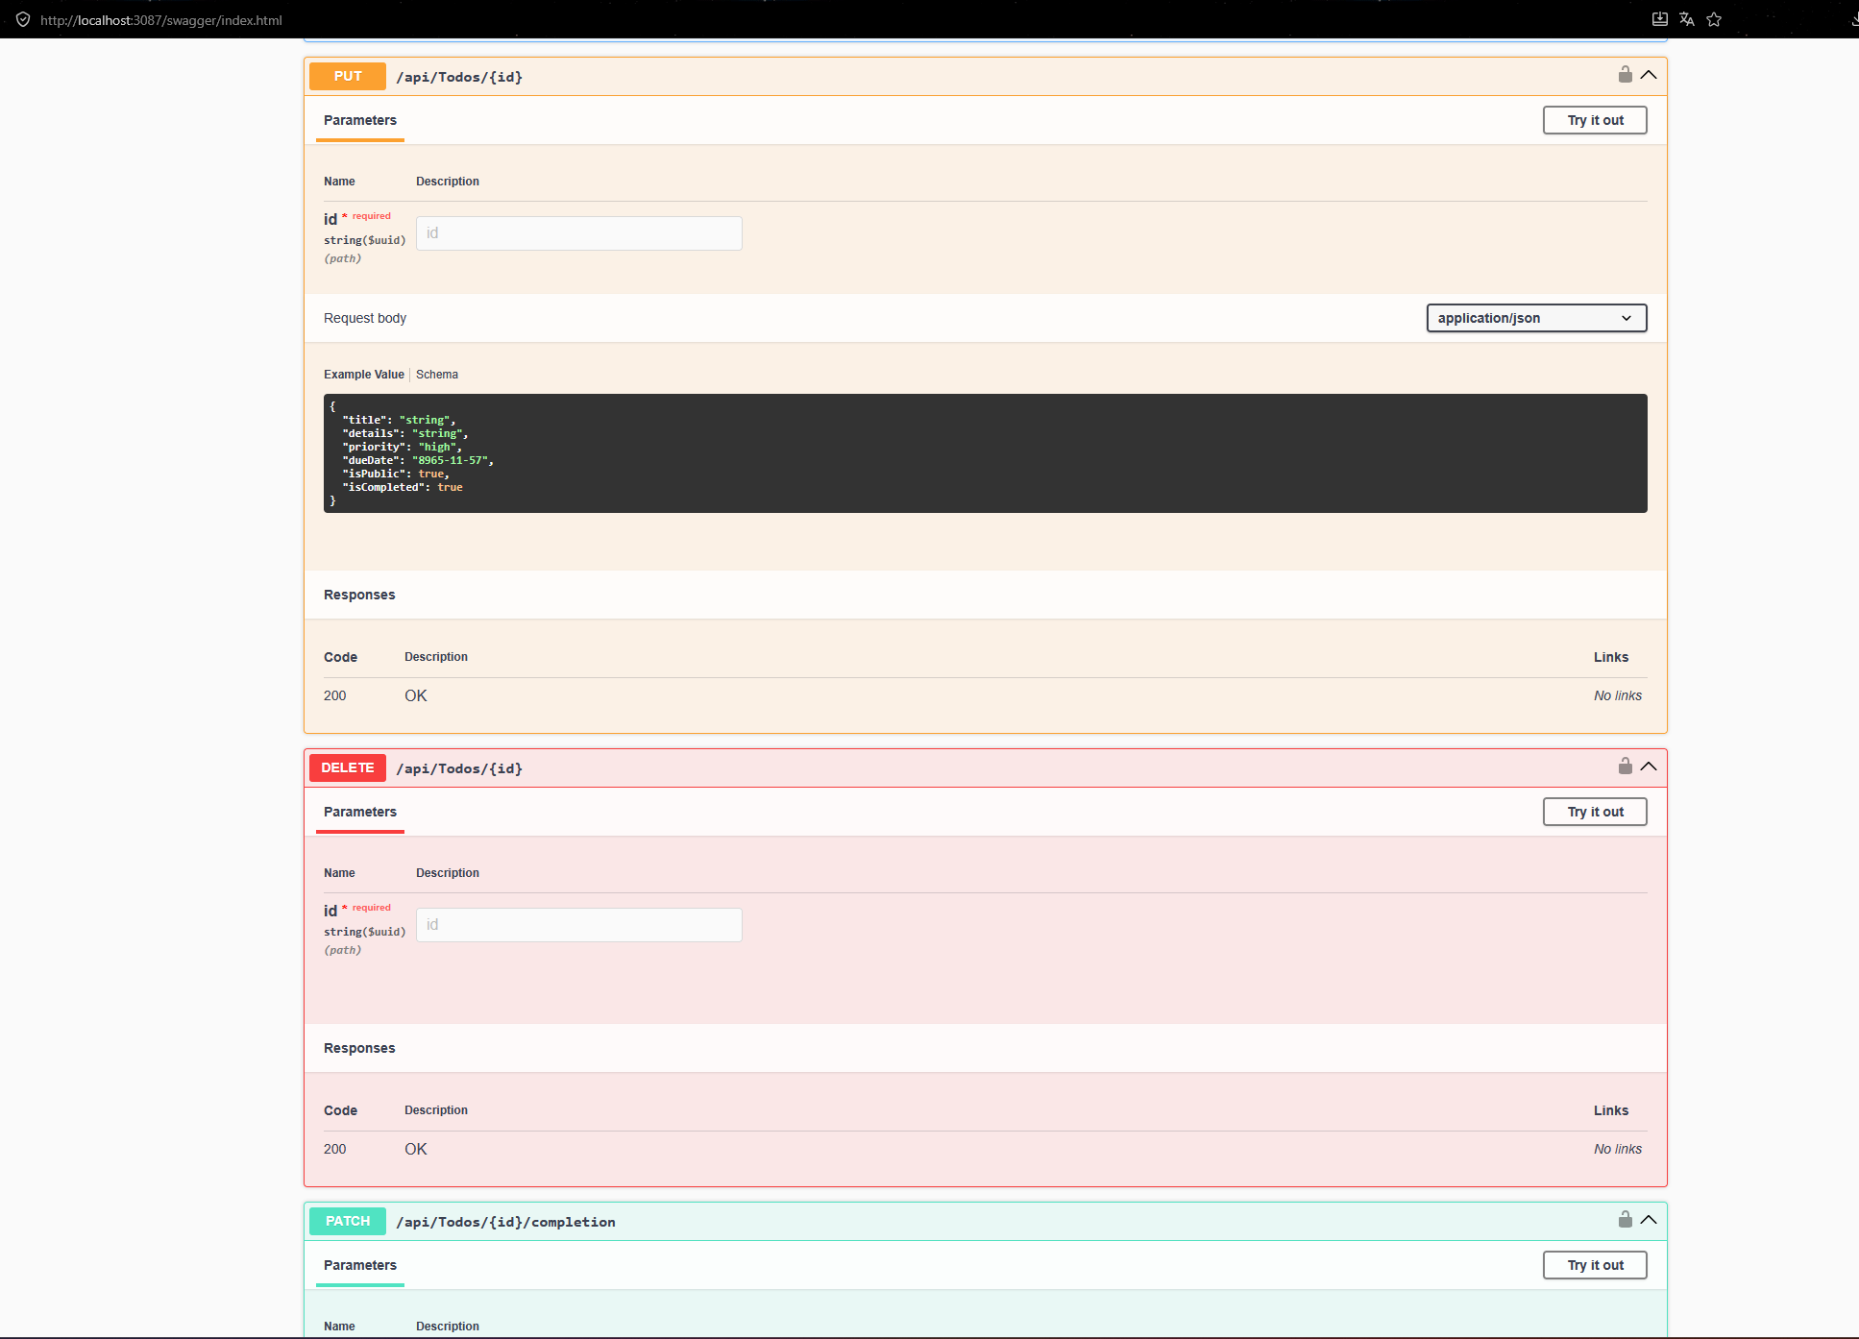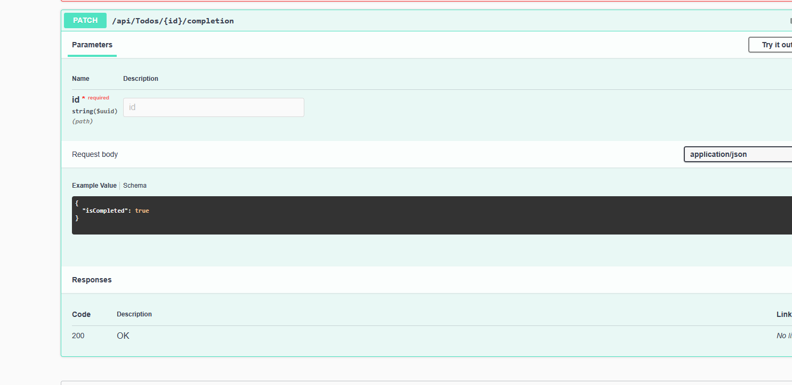
5. Bonus Integrations (+20 Points)
To enhance the application's performance and architecture, both optional bonus integrations were successfully implemented and containerized:
5.1 Redis Integration
Redis is utilized to cache the response of the public tasks list (GET /api/todos/public). This significantly reduces the database load for guest users.
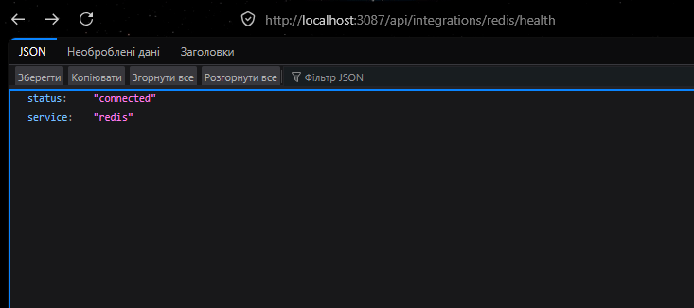
5.2 RabbitMQ Integration
RabbitMQ is integrated to support an event-driven architecture. The backend publishes domain events (TodoCreated, TodoUpdated, TodoCompleted, TodoDeleted) to a todo_events fanout exchange whenever a state change occurs in the tasks.
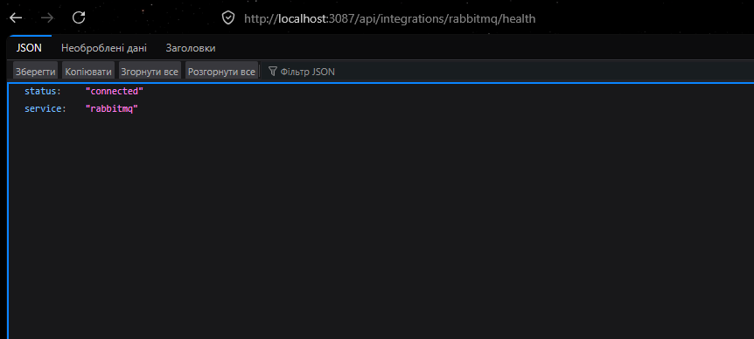
6. Automated E2E Testing (Cypress)
The provided Cypress test suite was executed against the backend to verify authentication, isolation, pagination, filtering, sorting, and full CRUD functionality. The backend strictly listens on port 3087 to ensure compatibility with the automated scoring system.